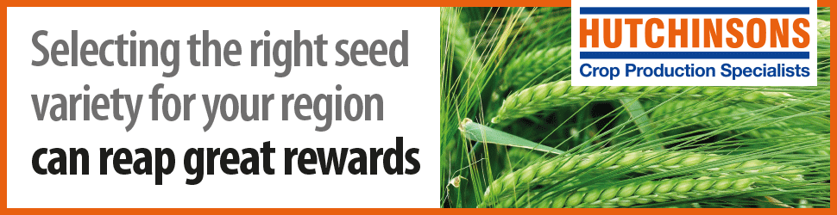

Hybrid Rye – Lewis McKerrow

Welcome to the Hybrid Rye stand.
Hybrid Rye offers potential as biogas feedstock, as an animal feed and as valuable part of our own food industry.

Hutchinsons is able to supply a comprehensive range of Hybrid Rye varieties as well as conventional/forage Rye. In our video below, agronomist Lewis McKerrow compares the growth of hybrid varieties ‘Su Performer’ and ‘Poseidon’ this summer.
What does Hybrid Rye offer farmers? (Courtesy of KWS)
Key rotational advantages:
- High grain yields of 10-13 t/ha - exceeding 2nd wheat
- Early harvest (whole crop) or grain (typically between winter barley and wheat)
- Ultra low take-all carry over (2nd lowest compared to oats)
- High black-grass suppression
- High straw yield (around 30% higher than wheat or barley)
- Ideal option for OSR establishment to ensure volunteer control
- Exceptional drought tolerance on light land.

2020 varieties:
KWS TAYO – A brand new addition from KWS, a multi-purpose hybrid (AD or grain, feed, flour and distilling).
KWS SERAFINO – Introduced in 2019, AD & grain variety. Excellent stem stiffness and brown rust resistance.
KWS PROPOWER – High yielding AD variety, similar biogas yield/tonne to maize.
KWS ETERNO – AD & Grain variety – High whole crop and grain yields, good brown rust resistance.
KWS EDMONDO – AD & Grain variety – No1 Harvest Index (grain/ear). Good stem stiffness and disease resistance.
SU ARVID – A new, candidate variety from Elsoms, strong agronomically, excellent results in whole crop situations.
SU COSSANI – Suited to later drilling slot and lighter land. Prostrate growth habit, very competitive. Best for baking.
SU PERFORMER – Highest yielding Saaten Union variety. Suited to heavier land and earlier drilling slot.
SU NASRI – Early maturing (4 days earlier than SU PERFORMER) Robust disease resistance. Good malting quality.
HELLTOP – High DM variety with excellent yield and standing power.
POSEIDON – Recently introduced variety from Nordic seeds. AHDB data suggests high yields and robust agronomics.
Contact us for further information on the benefits of growing Hybrid Rye and our seed options.

Contact Emails: lewis.mckerrow@hlhltd.co.uk / information@hlhltd.co.uk

Lewis McKerrow

Company website URL: https://www.hlhltd.co.uk/downloads/hutchinsons/Seed_brochure_2020.pdf
Facebook URL: HLHutchinsons
Twitter URL: @Hutchinsons_Ag

URL for company video: https://www.youtube.com/watch?time_continue=3&v=_8UXZynPAUE

