Introducing YEN Nutrition – A new grain analysis and benchmarking service

In time for harvest 2020, the team behind the Yield Enhancement Network (YEN) have launched a new initiative called YEN Nutrition – to support those seeking to improve the nutrition of arable crops.
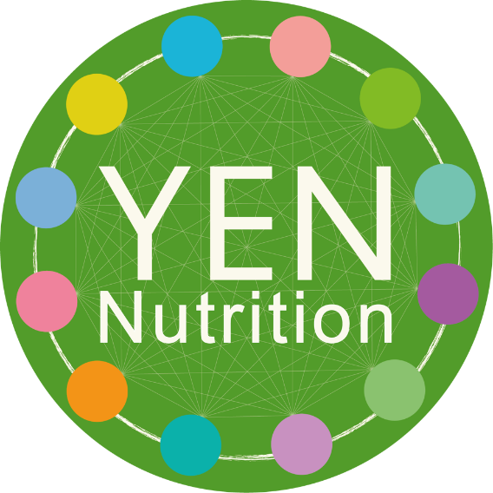
YEN Nutrition provides comprehensive grain analysis on all 12 essential crop nutrients and allows participants to benchmark their crops’ nutritional performance against other growers.
When used in conjunction with soil and leaf analysis, YEN Nutrition will reveal the final status of the crop, and empower growers to make the right nutritional choices to enhance their future crop yields, field by field.
Membership is open to anyone from the UK or abroad for any grain crop - cereals, oilseeds, or pulses.
VIDEO of Prof. Roger Sylvester-Bradley, Head of Crop Performance at ADAS, explaining YEN Nutrition

To learn more and get involved, please go to https://www.yen.adas.co.uk/projects/yen-nutrition

About the Yield Enhancement Network (YEN)

Since 2012, the YEN has supported and encouraged growers to achieve the most possible from their crops. Outside of YEN Nutrition, there are 6 networks within YEN that members can join – Grass, Cereal, Oilseed, Pea, Bean, and Potato.

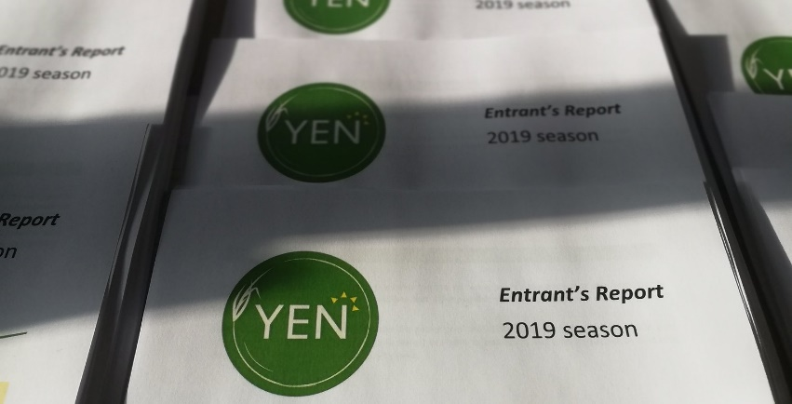
YEN allows members can compare their actual yield for the year with their potential yield – the highest yield that could possibly have been achieved.

With the help of a end-of-year comprehensive bespoke performance report prepared by ADAS researchers, growers can see what prevented them from reaching their full yield potential.

Being part of YEN technical sessions and networking events with similar growers can help members find new ways to overcome these barriers so they can get closer to their full potential yield the following year.

To learn more about the YEN, please see our website www.yen.adas.co.uk

Meet the members
Check out the stories of two of our Scottish YEN members – David Fuller-Shapcott from Sweethorpe and Peter Chapman from Redbog.

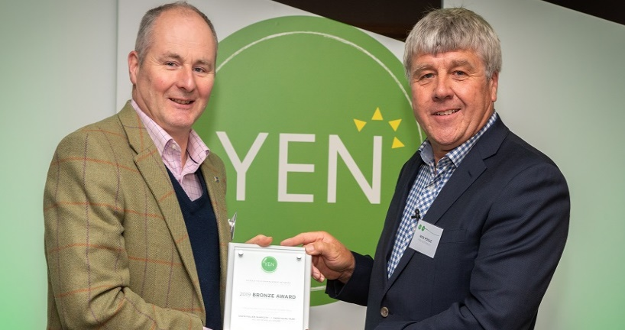
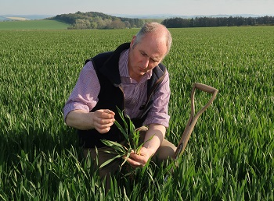

David Fuller-Shapcott farms JN Fuller-Shapcott & Co, a family-farm of 369ha at Sweethope in Scotland. David, with the support of BASF, came third in the UK last year for achieving the best potential OSR yield from his field (63% of 10.1 tonnes per hectare). Have a read of David’s story and why he got involved in the YEN.
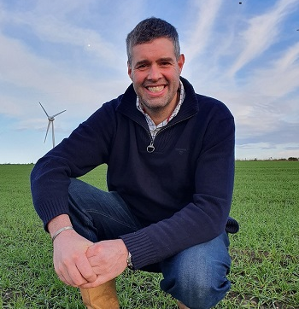
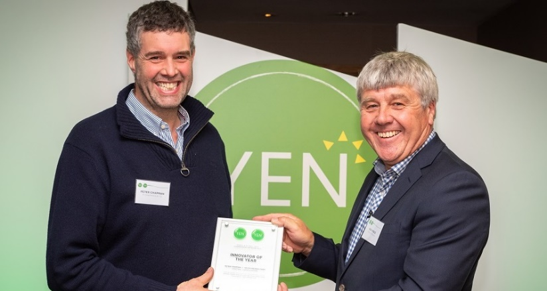

Peter Chapman farms 1,050 acres in Redbog, Scotland. Peter won our YEN Innovator of the Year award last year for his work on starting a Spring Barley network and for initiating the Scottish YEN growers group. Peter feels that the group has been really successful with Scottish growers punching above their weight when it comes to yield. Have a read of Peter’s story

