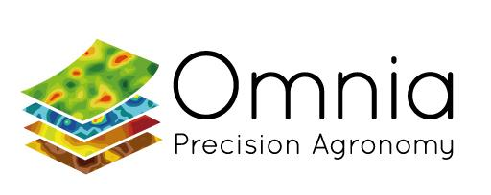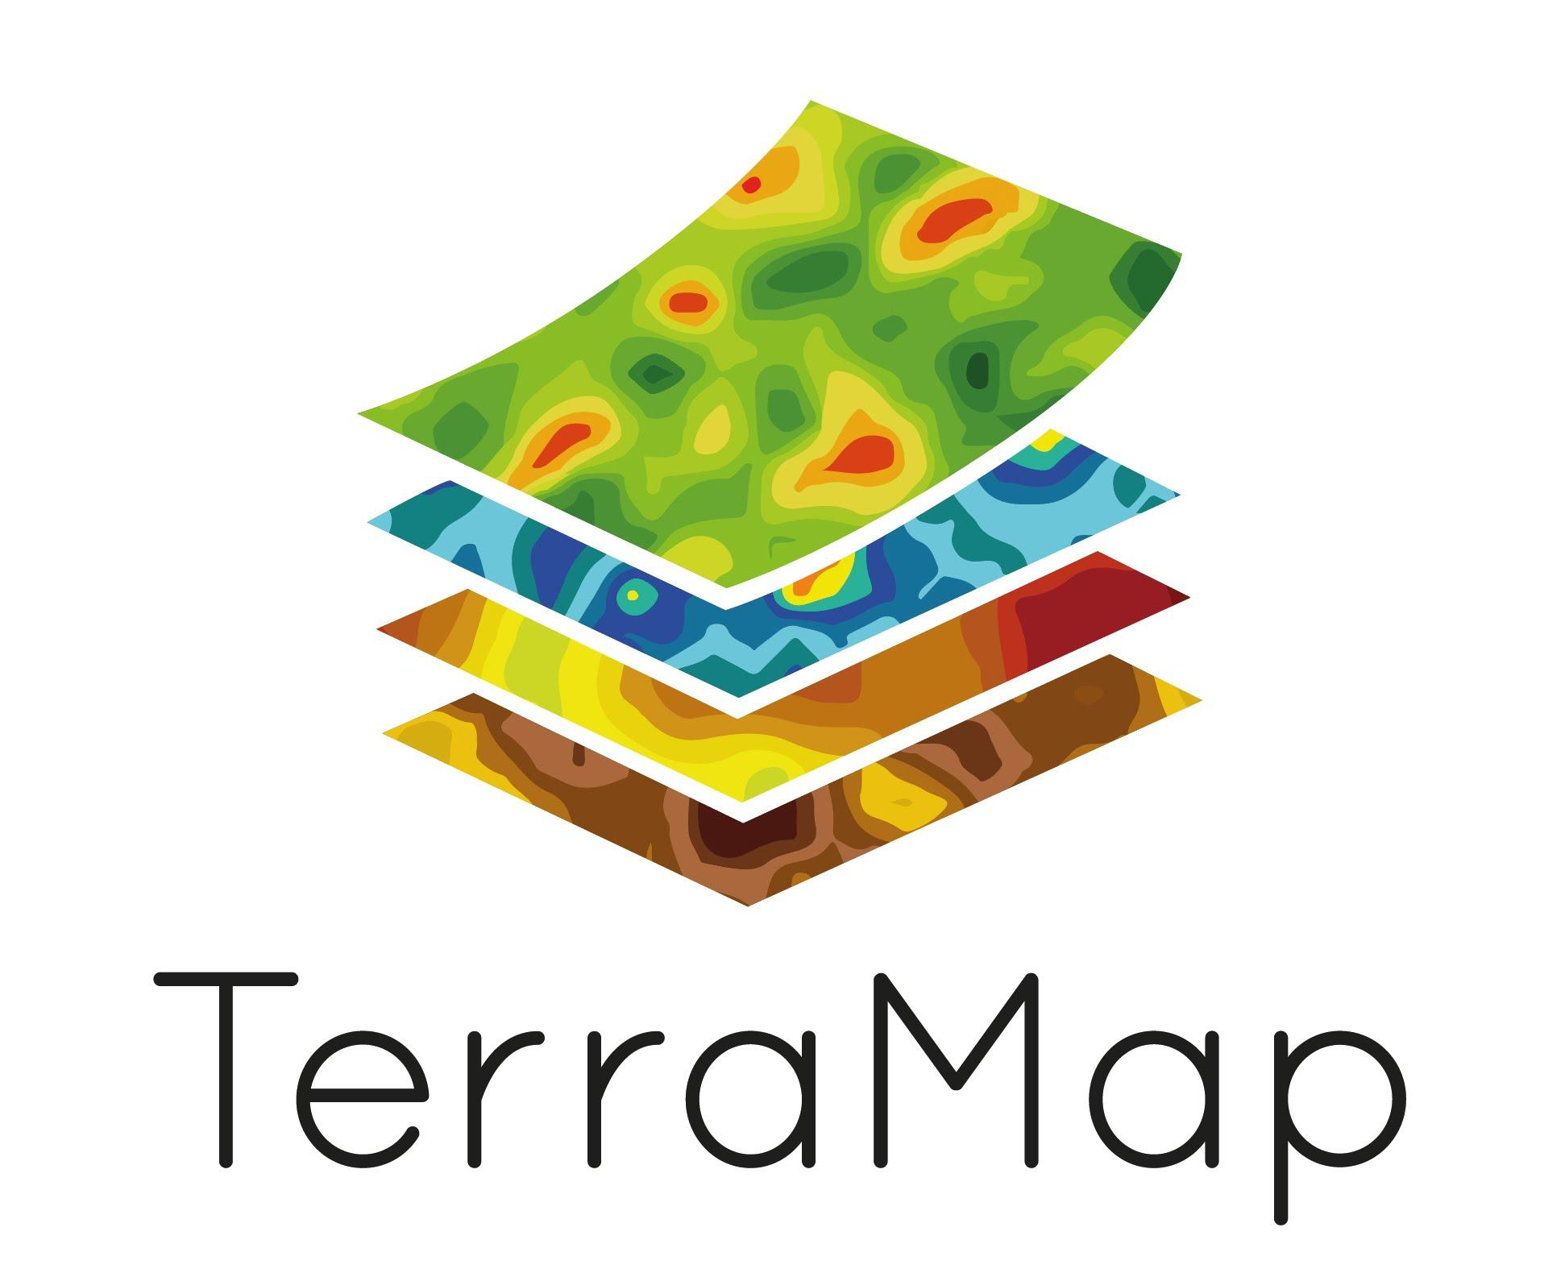
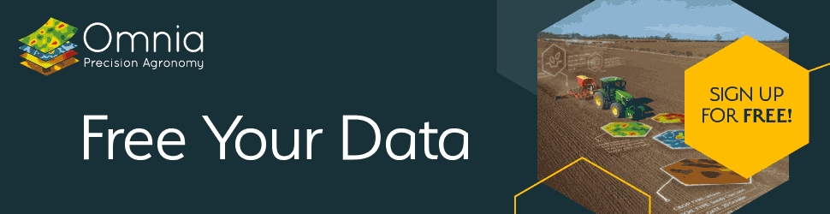

Omnia (TerraMap & Climate Module) - Lewis McKerrow

Welcome to the Omnia (TerraMap & Climate Module) stand.
The central idea behind Omnia was to create a platform which could host, manage and inform, rather than just store data, putting the user in control. As a result, we decided early on to adopt an open approach, developing Omnia to connect to other cloud-based systems so that all data sources could be utilised. Omnia has a number of import and export features to transfer data with a wide range of machines and platforms. It can be accessed on-line from any device, making it very practical for making changes. While Omnia has been designed for self-reliance, it can also be operated by an agronomist or advisor and can be used for whole-field or precision management.

TerraMap enables agronomists and growers to make the most of precision technology. TerraMap produces the world’s highest resolution soil maps, mapping layers at over 800 data points per hectare.
TerraMap uses passive, gamma-ray detection technology, providing high-definition mapping of all common nutrient properties, pH, soil texture, organic matter and CEC as well as elevation and plant available water. It measures naturally emitted isotopes, like Caesium and Potassium, that are very stable due to their long half-lives. The significance of this methodology is that it is not affected by soil moisture, compaction, crop cover or cultivation state. This means that there are very few limitations to when TerraMap can be used – offering a much wider operating window for soil scans compared to other soil scanning systems, and the consistency and reliability of the results from TerraMap are proven across many years and hectares

Contact Emails: lewis.mckerrow@hlhltd.co.uk / information@hlhltd.co.uk

Lewis McKerrow 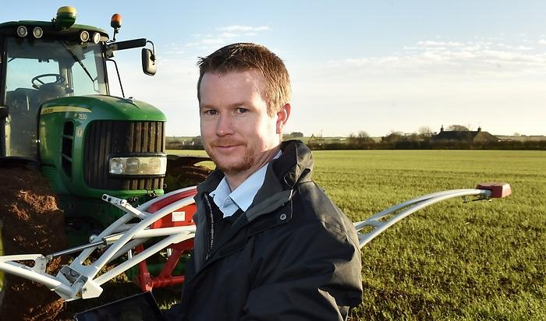

Company website URL: https://www.omniaprecision.co.uk/

URL for company video: Morven Anderson Climate Module - YouTube: https://youtu.be/qzVMSU0OtiE

